**Ideation Phase**

**Define the Problem Statements**

|  |  |
| --- | --- |
| Date | 29 September 2022 |
| Team ID | PNT2022TMID26431 |
| Project Name | Project – Personal Expense Tracker |
| Maximum Marks | 2 Marks |

**Customer Problem Statement Template:**

This study is aimed at developing a cloud-based application capable of monitoring and controlling personal expenses, as well as cautioning the user against reckless and unbudgeted spending. The application allows users to track their expenses daily, weekly, monthly, and yearly in terms of summary, bar graphs, and pie-charts.

|  |  |
| --- | --- |
| **I am** | User, need to reduce unwanted expenses and save money. |
| **I’m trying to** | Needs to monitor and control expenses in day-to-day life. |
| **But,** | It takes long time to load and I couldn’t get time to analyse every expense I made. And reading or viewing each expenses every time was not confortable for me in eachtime. |
| **Because** | I am not comfortable with listing each day expenses and can’t find an appropriate way to handle it. |
| **Which makes me feel** | I consider listing a expense manually are frustrated to use the application. |

**Reference:** <https://miro.com/app/board/uXjVPSnCmhI=/?share_link_id=535409691240>

**Example:**

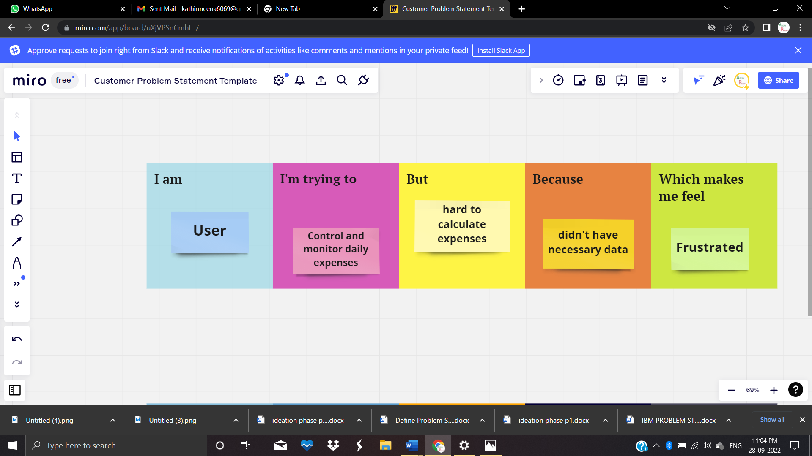

|  |  |  |  |  |  |
| --- | --- | --- | --- | --- | --- |
| **Problem Statement (PS)** | **I am** | **I’m trying to** | **But** | **Because** | **Which makes me feel** |
| PS-1 | User | Control daily expenses | Hard to calculate expenses | Didn’t have necessary data | Frustrated |
| PS-2 | User | Monitor expenses | All expenses are not recorded | Lack of required data | Irritated |